<https://thought-leadership-production.s3.amazonaws.com/2016/10/28/17/17/50/0615788b-8eaf-4b4f-a02a-8819c68278ef/20160825_PHA_Report_FINAL.pdf>

Urban trees:

* Soak up particle pollution, [a big problem](http://www.iea.org/publications/freepublications/publication/WorldEnergyOutlookSpecialReport2016EnergyandAirPollution.pdf) to health, [generally improving air quality](http://www.fs.fed.us/nrs/pubs/jrnl/2013/nrs_2013_nowak_002.pdf)
* Decrease temp of surrounding areas by multiple degrees, [enough to save lives on the margin](http://apps.who.int/iris/bitstream/10665/42792/1/9241580348_eng_Volume1.pdf), in addition to providing a cooler place to live
  + Almost certainly would bring down energy costs in regions that use air conditioning, saving money and mitigating climate change
* Retain storm water, boost property value, and possibly [provide mental-health benefits](https://www.ncbi.nlm.nih.gov/pubmed/22320203)

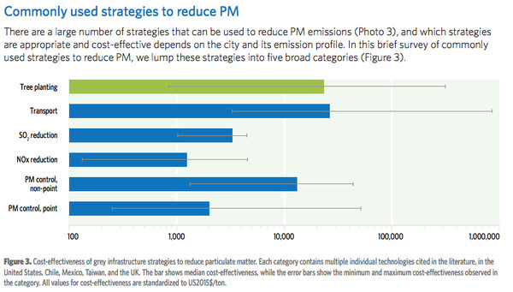

BUT:

* Has to in right place, with right trees
  + Only improve air quality in immediately area, ~30 meters
    - Prioritize dense areas
  + Pollution-trapping trees, ie ones with large trees
  + Trees can consume significant water, and if its limited, a city needs drought-tolerant species
  + [Prioritize less allergenic species](https://www.ncbi.nlm.nih.gov/pubmed/26310854)

Despite this:

* [Declining tree density](https://www.itreetools.org/Canopy/resources/Tree_and_Impervious_Cover_change_in_US_Cities_Nowak_Greenfield.pdf) in US, and globally. Wealthier European nations are the biggest exception.
  + [Largely due to emerald ash borer](https://www.washingtonpost.com/news/energy-environment/wp/2016/05/10/the-slow-motion-crisis-thats-facing-u-s-forests/)
    - Damage can be mitigated by diversifying trees